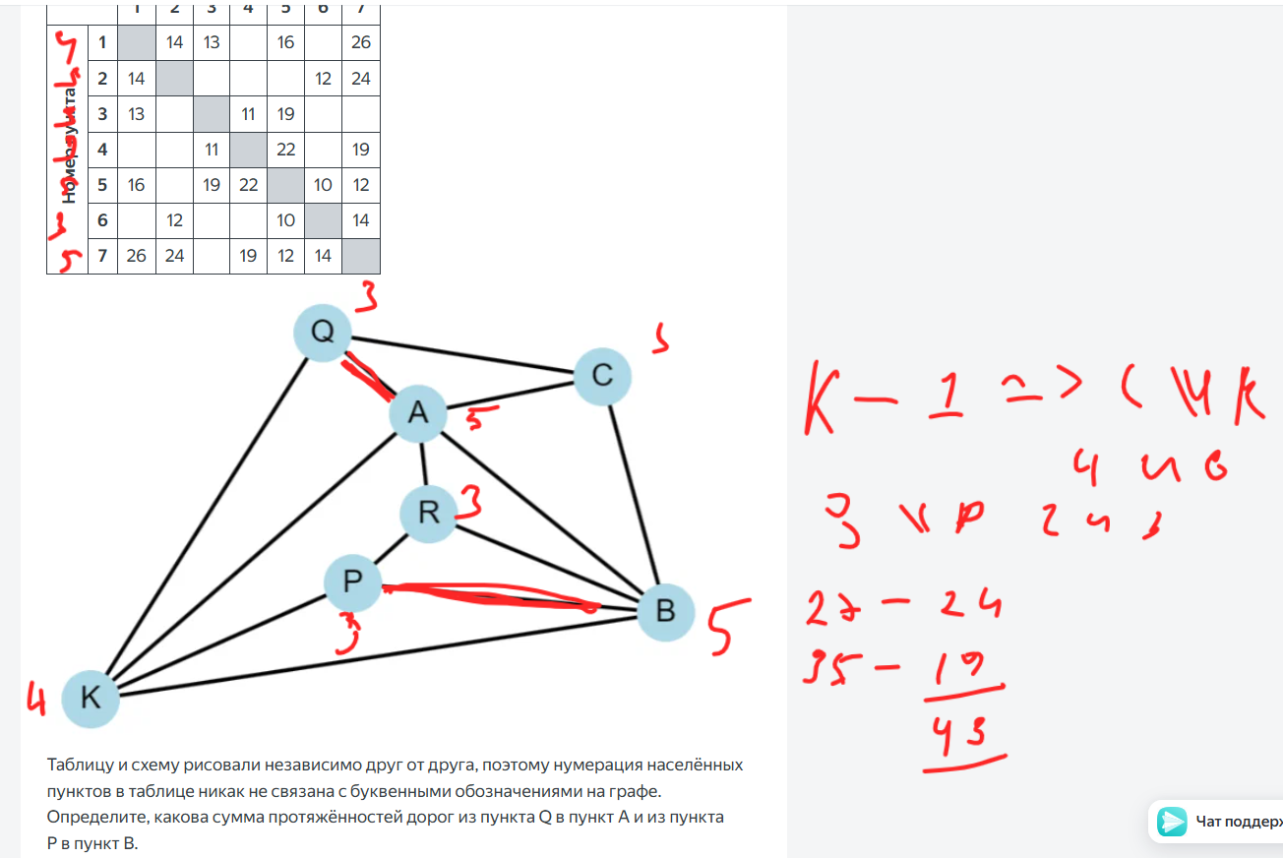

|  |  |  |  |  |  |  |  |  |  |  |  |  |  |  |  |
| --- | --- | --- | --- | --- | --- | --- | --- | --- | --- | --- | --- | --- | --- | --- | --- |
|  | Кол-во | Код | Итог | Кол-во | Код | Итог |  |  |  |  |  |  |  |  |  |
| **П** | 1 | 1000 | 4 | 1 | 100 | 3 |  |  |  |  |  |  |  |  |  |
| **А** | 2 | 11 | 4 | 2 | 101 | 6 |  |  |  |  |  |  |  |  |  |
| **Р** | 1 | 1001 | 4 | 1 | 110 | 3 |  |  |  |  |  |  |  |  |  |
| **Л** | 3 | 0 | 3 | 2 | 0 | 2 |  |  |  |  |  |  |  |  |  |
| **Е** | 1 | 1010 | 4 | 1 | 1110 | 4 |  |  |  |  |  |  |  |  |  |
| **Ь** | 1 | 1011 | 4 | 1 | 1111 | 4 |  |  |  |  |  |  |  |  |  |
|  |  |  | 23 |  |  | 22 |  |  |  |  |  |  |  |  |  |

